BUG REPORT – COVID-19 TRACKER

BUG_01 – DATA INCONSISTENCY BETWEEN TOTAL CASES AND CASE CATEGORIES ACROSS MULTIPLE STATES
FIELD | DETAILS
BUG ID | BUG_01
BUG TITLE | DATA INCONSISTENCY BETWEEN TOTAL CASES AND CASE CATEGORIES ACROSS MULTIPLE STATES
SEVERITY | MAJOR
PRIORITY | HIGH
STATUS | OPEN
MODULE | COVID-19 DATA CARDS
TEST DATA | BIHAR, ASSAM, KARNATAKA, KERALA, MAHARASHTRA, MEGHALAYA, NAGALAND, SIKKIM, TRIPURA, UTTARAKHAND
STEPS TO REPRODUCE:
- OPEN https://inerg-test.web.app/
- SELECT ANY STATE LISTED IN THE TEST DATA FROM THE STATE DROPDOWN..
- OBSERVE THE COVID-19 DATA CARDS.
- NOTE THE VALUES FOR TOTAL CASES, ACTIVE CASES, RECOVERED AND DEATHS.
- ADD THE ACTIVE CASES, RECOVERED AND DEATHS VALUES.
- COMPARE THE CALCULATED SUM WITH THE DISPLAYED TOTAL CASES.
- REPEAT THE SAME VALIDATION FOR OTHER STATES
EXPECTED RESULT:
THE TOTAL CASES SHOULD MATCH THE SUM OF ACTIVE CASES, RECOVERED CASES AND DEATHS FOR EACH SELECTED STATE.
ACTUAL RESULT:
THE DISPLAYED TOTAL CASES DO NOT MATCH THE SUM OF ACTIVE CASES, RECOVERED CASES AND DEATHS FOR MULTIPLE STATES. DATA INCONSISTENCIES WERE OBSERVED IN BIHAR, ASSAM, KARNATAKA, KERALA, MAHARASHTRA, MEGHALAYA, NAGALAND, SIKKIM, TRIPURA AND UTTARAKHAND.

AFFECTED STATES
STATE | DISPLAYED TOTAL | CALCULATED TOTAL | DIFFERENCE
BIHAR | 212,705 | 212,704 | 1
ASSAM | 204,386 | 204,383 | 3
KARNATAKA | 805,947 | 805,928 | 19
KERALA | 397,218 | 397,115 | 103
MAHARASHTRA | 1,648,665 | 1,648,145 | 520
MEGHALAYA | 9,020 | 9,017 | 3
NAGALAND | 8,663 | 8,580 | 83
SIKKIM | 3,840 | 3,758 | 82
TRIPURA | 30,254 | 30,231 | 23
UTTARAKHAND | 60,744 | 60,269 | 475

SCREENSHOTS/ EVIDENCES:
EVIDENCE 1- BIHAR
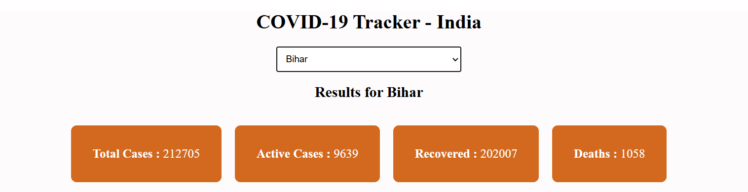
9,639 + 202,007 + 1,058 = 212,704
DISPLAYED TOTAL CASES = 212,705
DIFFERENCE = 1 CASE

EVIDENCE 2- KERALA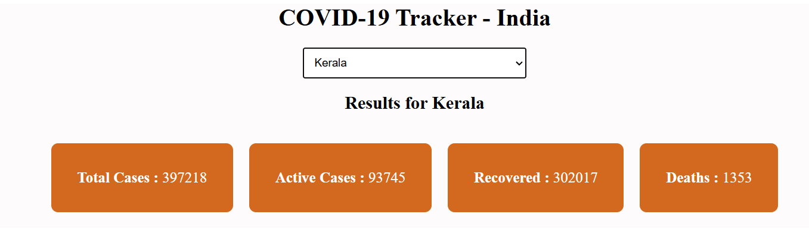
93,745 + 302,017 + 1,353 = 397,115
DISPLAYED TOTAL CASES = 397,218
DIFFERENCE = 103 CASES

EVIDENCE 3- MAHARASHTRA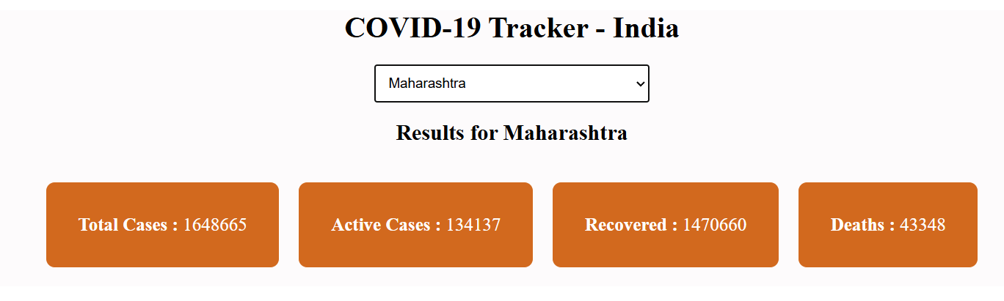
CALCULATION
134,137 + 1,470,660 + 43,348 = 1,648,145
DISPLAYED TOTAL CASES = 1,648,665
DIFFERENCE = 520 CASES
BUG_02 – LINE CHART DOES NOT DISPLAY CONNECTING LINES BETWEEN DATA POINTS
FIELD | DETAILS
BUG ID | BUG_02
BUG TITLE | LINE CHART DOES NOT DISPLAY CONNECTING LINES BETWEEN DATA POINTS
SEVERITY | MAJOR
PRIORITY | MEDIUM
STATUS | OPEN
MODULE | LINE CHART
TEST DATA | KERALA
STEPS TO REPRODUCE:
- OPEN https://inerg-test.web.app/
- SELECT KERALA FROM THE STATE DROPDOWN.
- SCROLL TO THE LINE CHART SECTION.
- OBSERVE THE DATA POINTS DISPLAYED IN THE LINE CHART.
- CHECK WHETHER THE DATA POINTS ARE CONNECTED BY LINES.
EXPECTED RESULT:
THE LINE CHART SHOULD DISPLAY THE DATA POINTS WITH CONNECTING LINES TO PROVIDE A CLEAR LINE-BASED REPRESENTATION OF THE COVID-19 CASE DATA.
ACTUAL RESULT:
THE LINE CHART DISPLAYS THE COVID-19 CASE VALUES AS INDIVIDUAL DATA POINTS WITHOUT CONNECTING LINES. THE DATA IS THEREFORE NOT VISUALLY REPRESENTED AS A LINE CHART
SCREENSHOT/ EVIDENCE:
EVIDENCE – KERALA LINE CHART

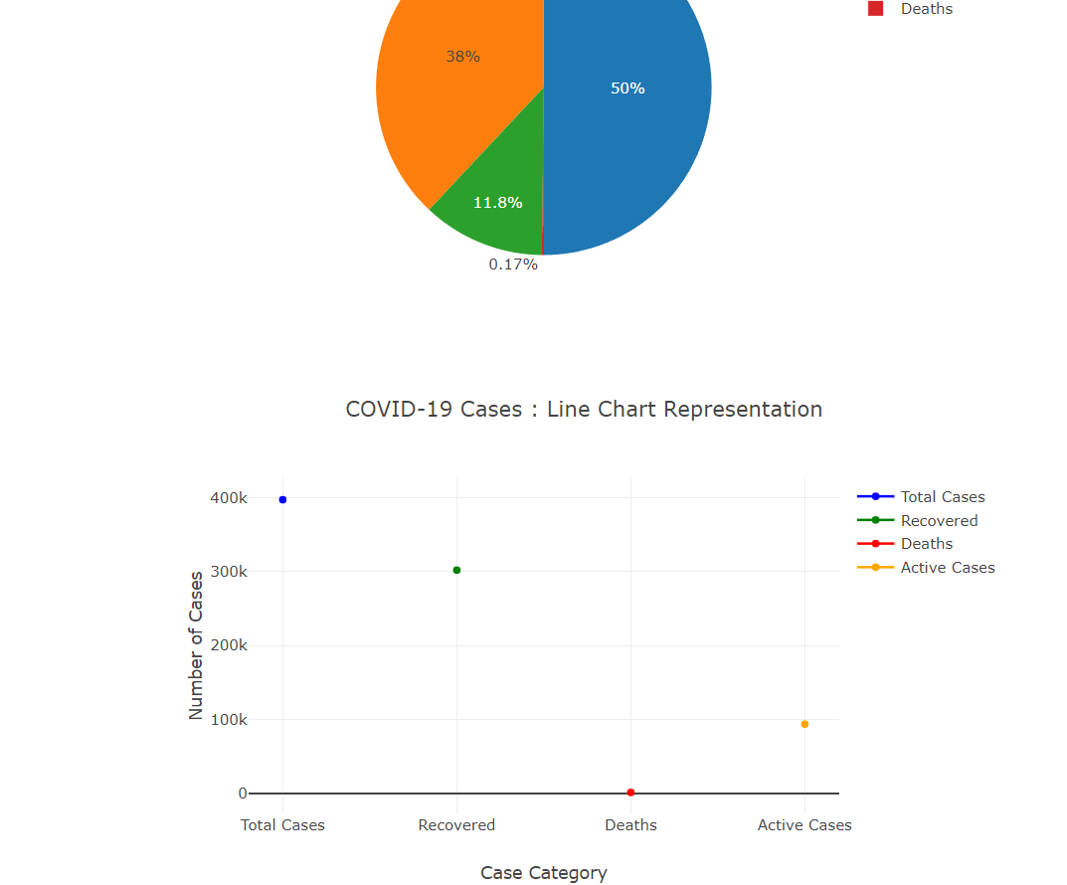

BUG_03 – PIE CHART INCLUDES TOTAL CASES AS A SEPARATE SLICE
FIELD | DETAILS
BUG ID | BUG_03
BUG TITLE | PIE CHART INCLUDES TOTAL CASES AS A SEPARATE SLICE
SEVERITY | MAJOR
PRIORITY | MEDIUM
STATUS | OPEN
MODULE | COVID-19 DISTRIBUTION PIE CHART
TEST DATA | KERALA
STEPS TO REPRODUCE:
- OPEN https://inerg-test.web.app/
- SELECT KERALA FROM THE STATE DROPDOWN.
- SCROLL TO THE COVID-19 DISTRIBUTION PIE CHART.
- OBSERVE THE CATEGORIES DISPLAYED IN THE PIE CHART.
- CHECK WHETHER TOTAL CASES IS DISPLAYED AS A SEPARATE SLICE ALONG WITH ACTIVE CASES, RECOVERED AND DEATHS.
EXPECTED RESULT:
THE PIE CHART SHOULD REPRESENT THE INDIVIDUAL CASE CATEGORIES WITHOUT DISPLAYING TOTAL CASES AS A SEPARATE SLICE, AS TOTAL CASES REPRESENTS THE OVERALL VALUE OF THE OTHER CASE CATEGORIES.
ACTUAL RESULT:
THE PIE CHART DISPLAYS TOTAL CASES AS A SEPARATE SLICE ALONG WITH RECOVERED, ACTIVE CASES AND DEATHS. TOTAL CASES REPRESENTS THE OVERALL NUMBER OF CASES, BUT IT IS ALSO INCLUDED AS A SEPARATE PORTION OF THE PIE CHART, RESULTING IN A MISLEADING DATA REPRESENTATION.

SCREENSHOT / EVIDENCE:

EVIDENCE – KERALA PIE CHART
